ProjectWise Network Configuration for LaDOTD connections
Effective June 1, 2023, Louisiana DOTD no longer provides a Windows registry file to consultants containing requisite ProjectWise network configuration information to access its ProjectWise network.
Instead, consultants will need to use the ProjectWise Network Configuration Settings dialog to add these settings. It is available from within ProjectWise via the Tools menu, Network Configuration Settings command, or from within the Windows Control Panel, under the Network and Internet section.
The Louisiana DOTD ProjectWIse network now only supports connections from ProjectWise Explorer Connect Edition versions, and ProjectWise V8i SS4. The screen captures shown in this document are from ProjectWise Explorer Connect Edition Release 3.2 on Windows 10. The dialog may vary slightly in other versions but adding the connection information is virtually the same for all versions.

General tab
To make changes that will apply to all users of the computer, or if the Allow users to modify settings option is not checked, click the Run as administrator button. You must have adequate Windows permission to do this. If you cannot Run as administrator, and the Allow users to modify settings options is not checked, you will need to contact your organization's technical support for assistance in making the changes shown in this document.
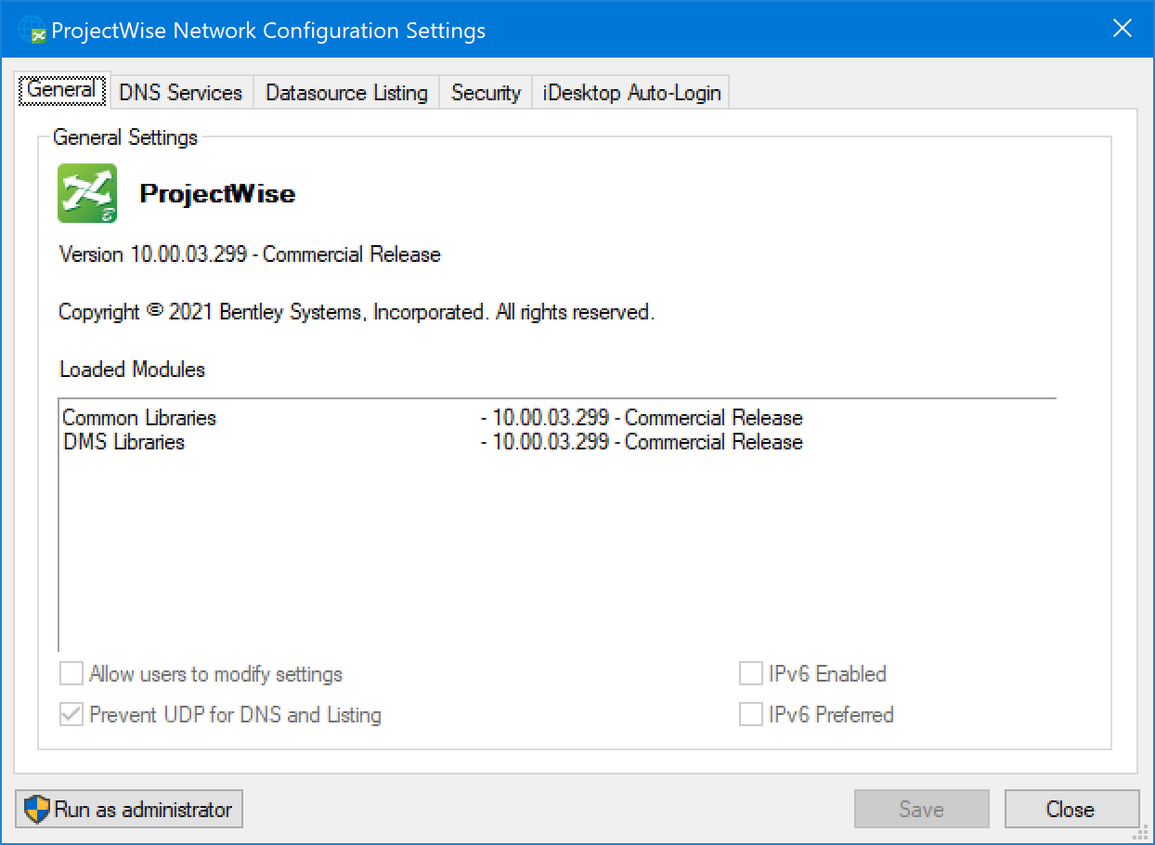
If you are allowed to modify settings as a user or clicked Run Administrator, the dialog will display options as shown below.
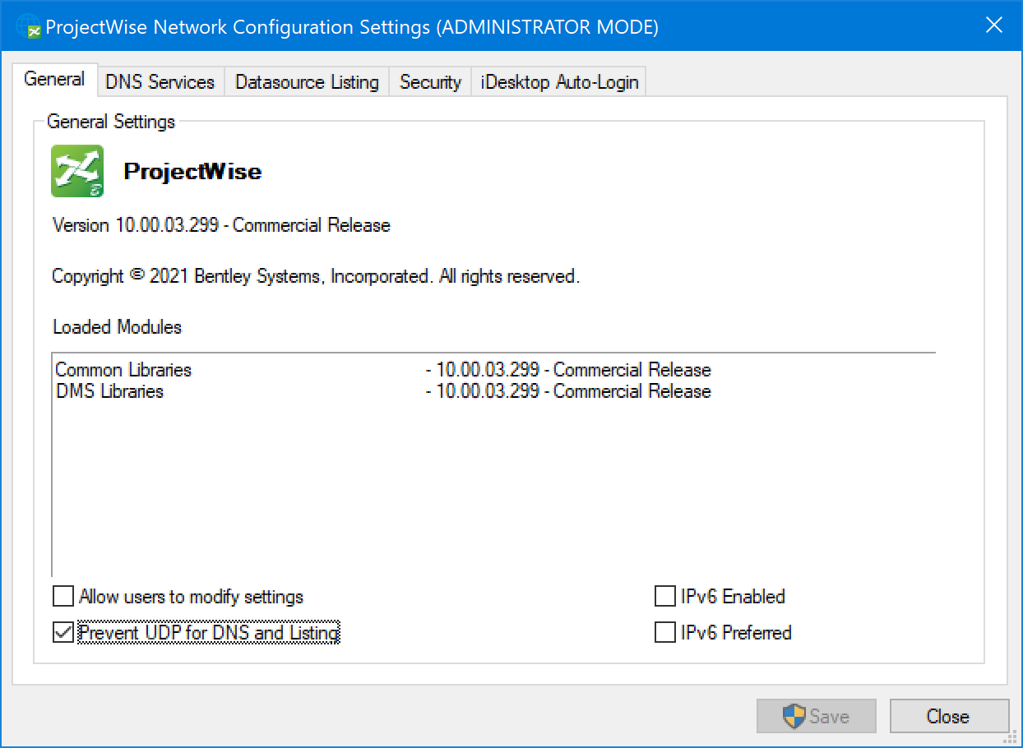
NOTE: the Prevent UDP option is not required to connect to Louisiana DOTD ProjectWise network. This also applies to the Prevent UDP option that appears on other tabs within the dialog.
NOTE: Louisiana DOTD ProjectWise network does not support IPv6.
DNS Services tab
Enter following information in the appropriate boxes in the dialog, then click Add.
Name*: LaDOTD
Hostname: pwweb.dotd.la.gov
Port: 5800
*Name can be anything of your choosing; LaDOTD is used in this example
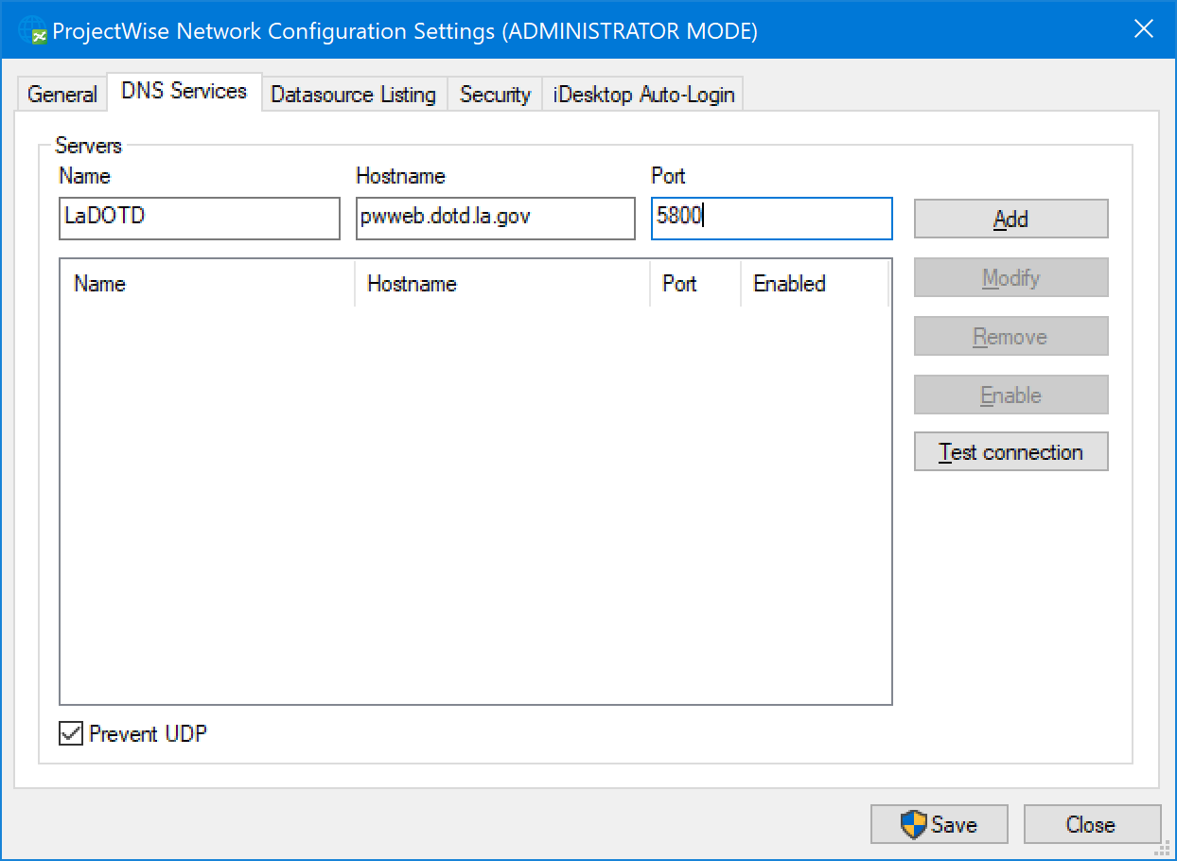
The network connection information appears in the list after it is added. If you already connect to other ProjectWise networks, your list will also show those.
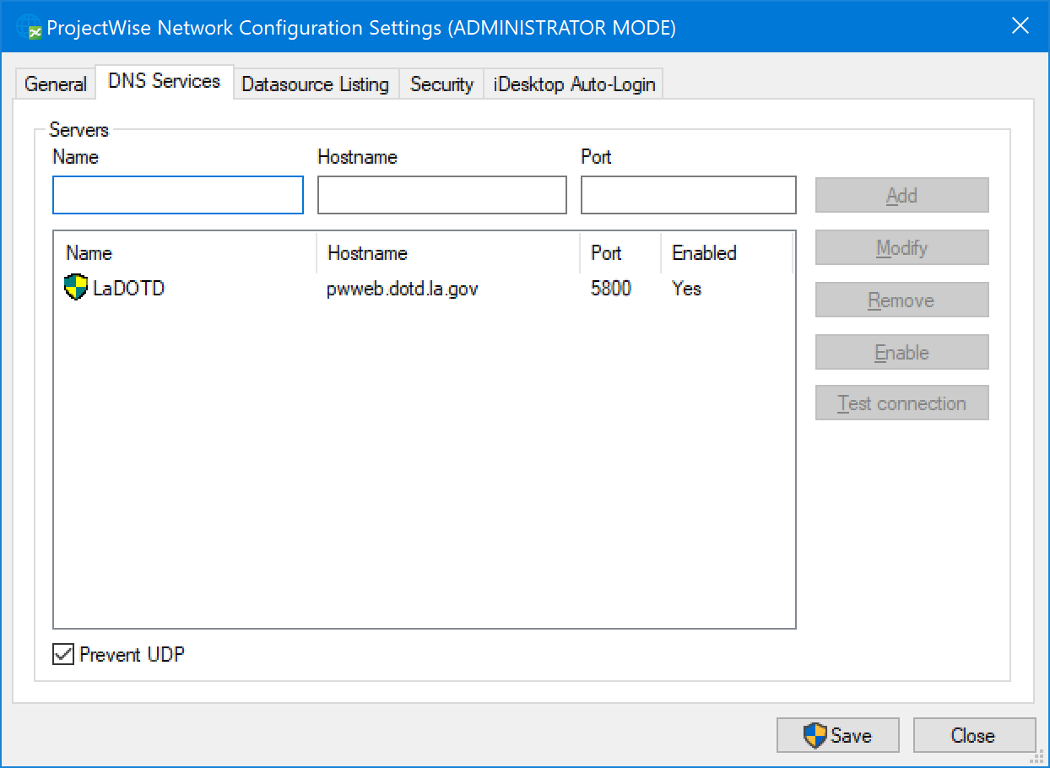
Datasource Listing tab
Enter following information in the appropriate boxes in the dialog, then click Add.
Name*: LaDOTD
Hostname: pwweb.dotd.la.gov
Port: 5800
*Name can be anything of your choosing; LaDOTD is used in this example
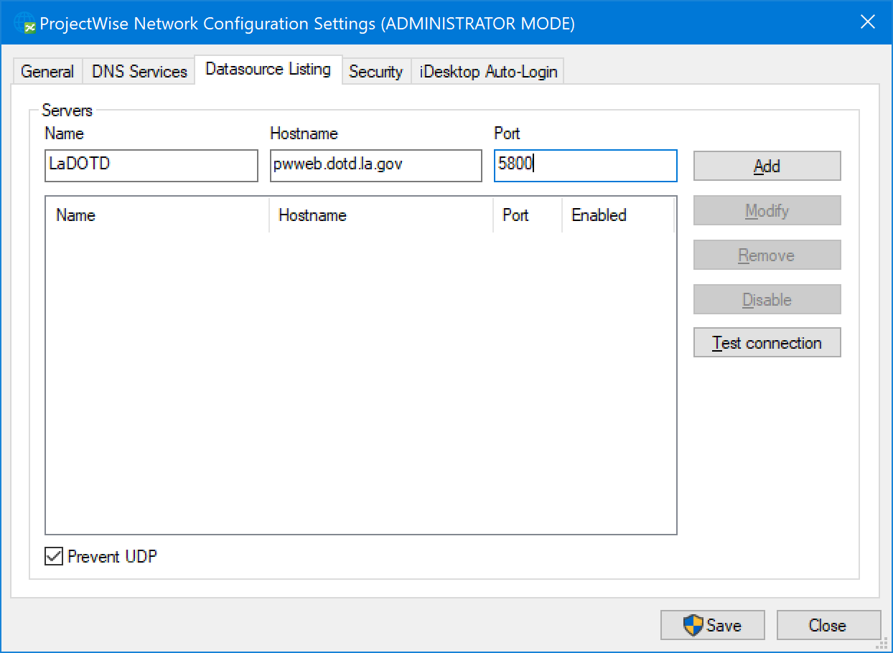
The network connection information appears in the list after it is added. If you already connect to other ProjectWise networks, your list will also show those.
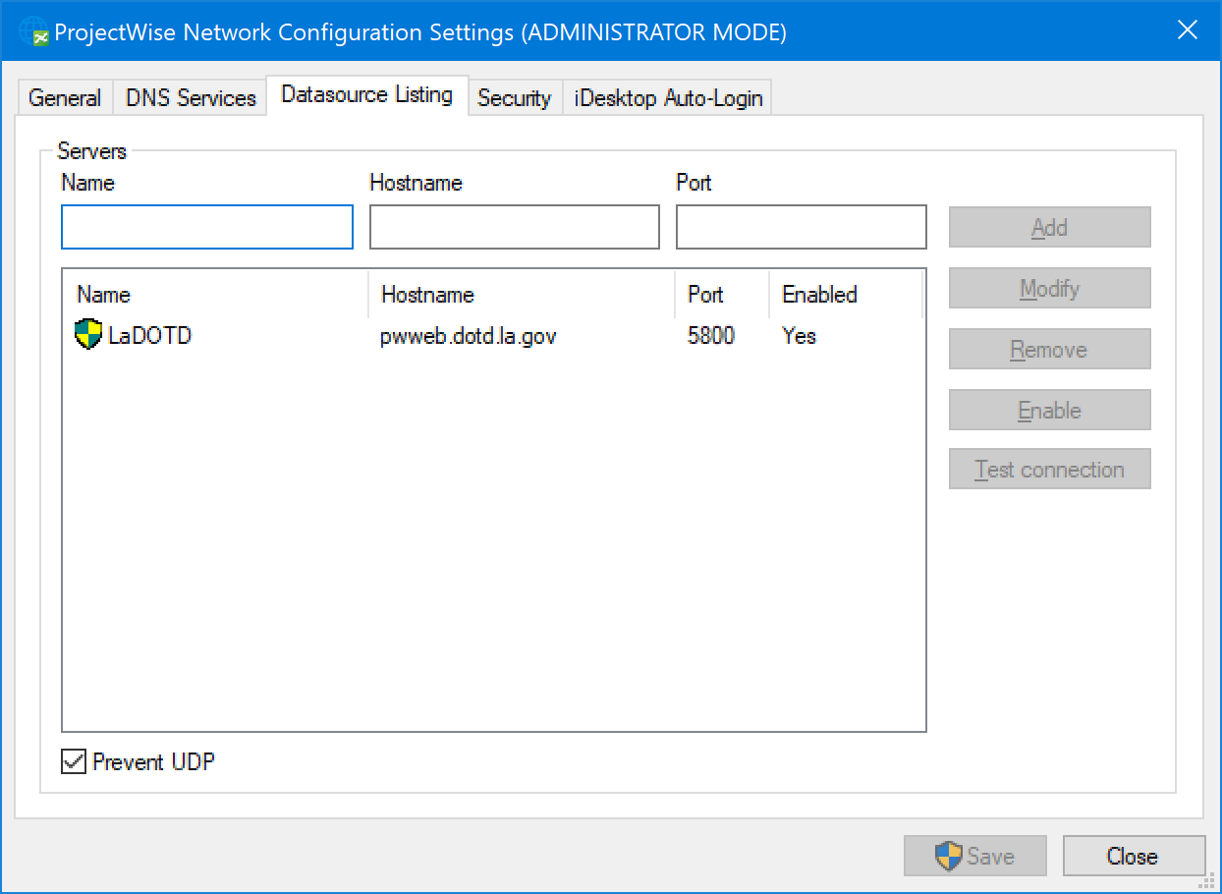
Security tab
If your ProjectWise Network Configuration Security requires secure connections to connect to other ProjectWise networks (the "Require secure connection (SSL/TLS) to datasources" setting is checked), you must add the Louisiana DOTD server information to the list of excepted servers. If the setting is not checked, no action is needed on this tab.
Enter following information in the appropriate boxes in the dialog, then click Add.
Name*: LaDOTD
Hostname: pwweb.dotd.la.gov
Port: 5800
*Name can be anything of your choosing; LaDOTD is used in this example
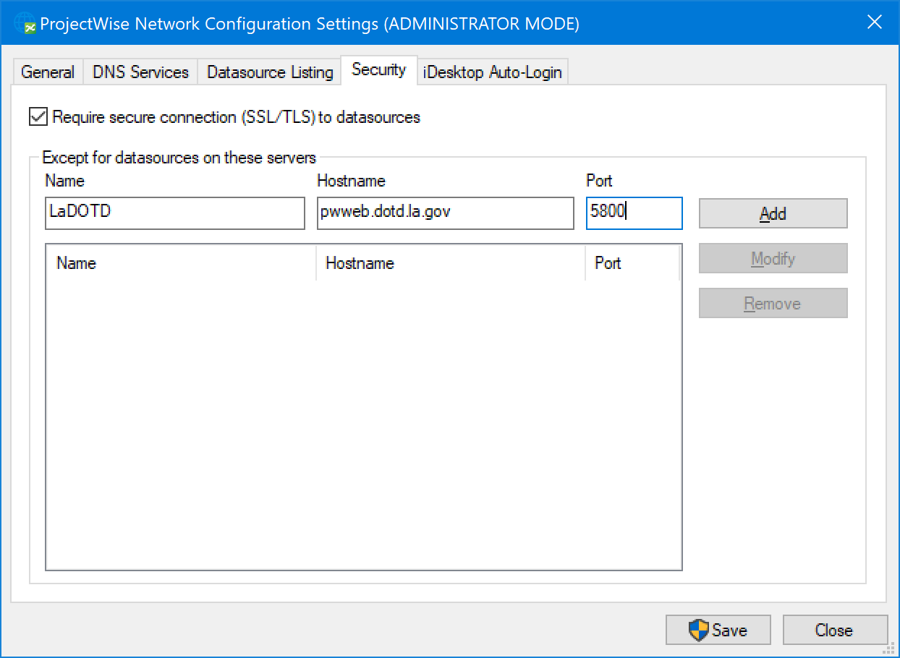
The excepted server connection information appears in the list after it is added. If you already connect to other ProjectWise networks that are excepted from the secure connection requirement, your list will also show those.
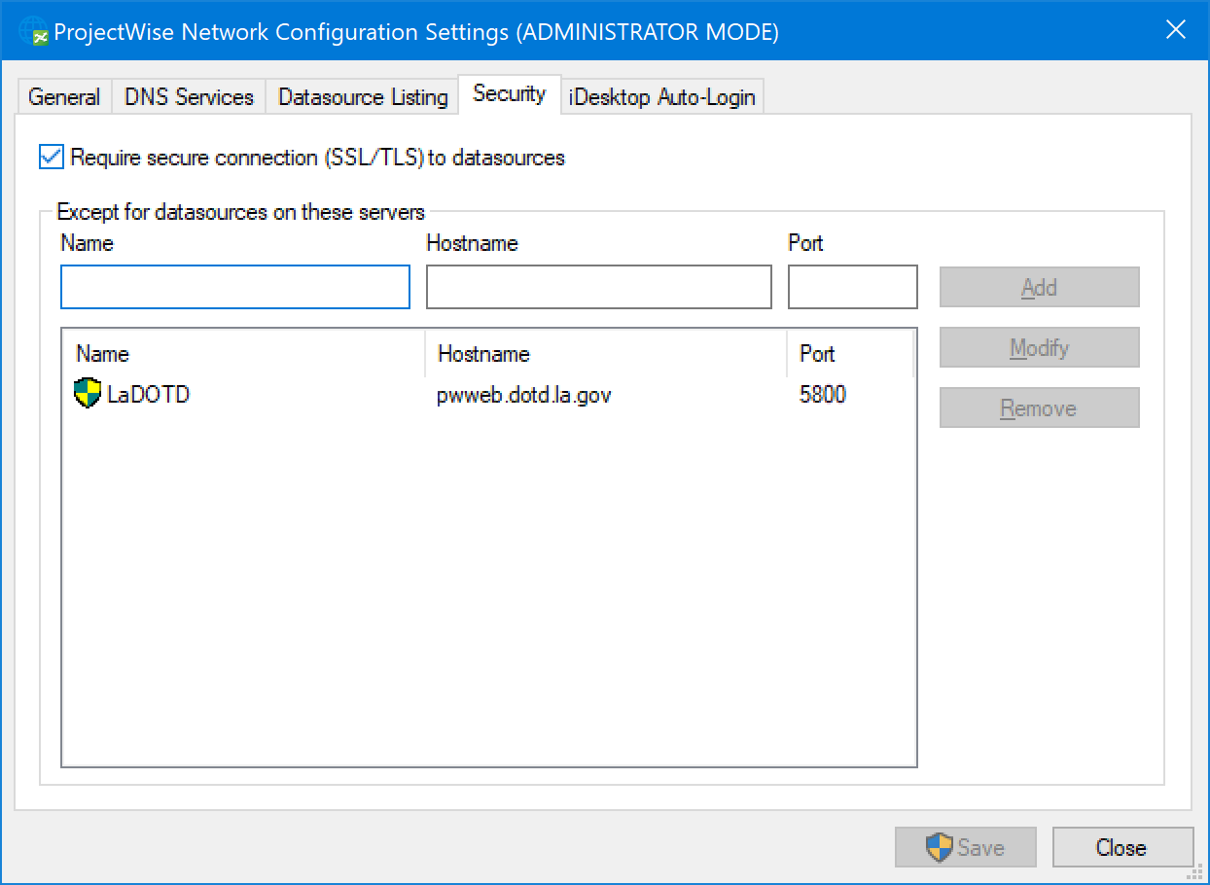

iDesktop Auto-Login tab
These settings are optional and are not required to be configured for connection to the Louisiana DOTD ProjectWise network.
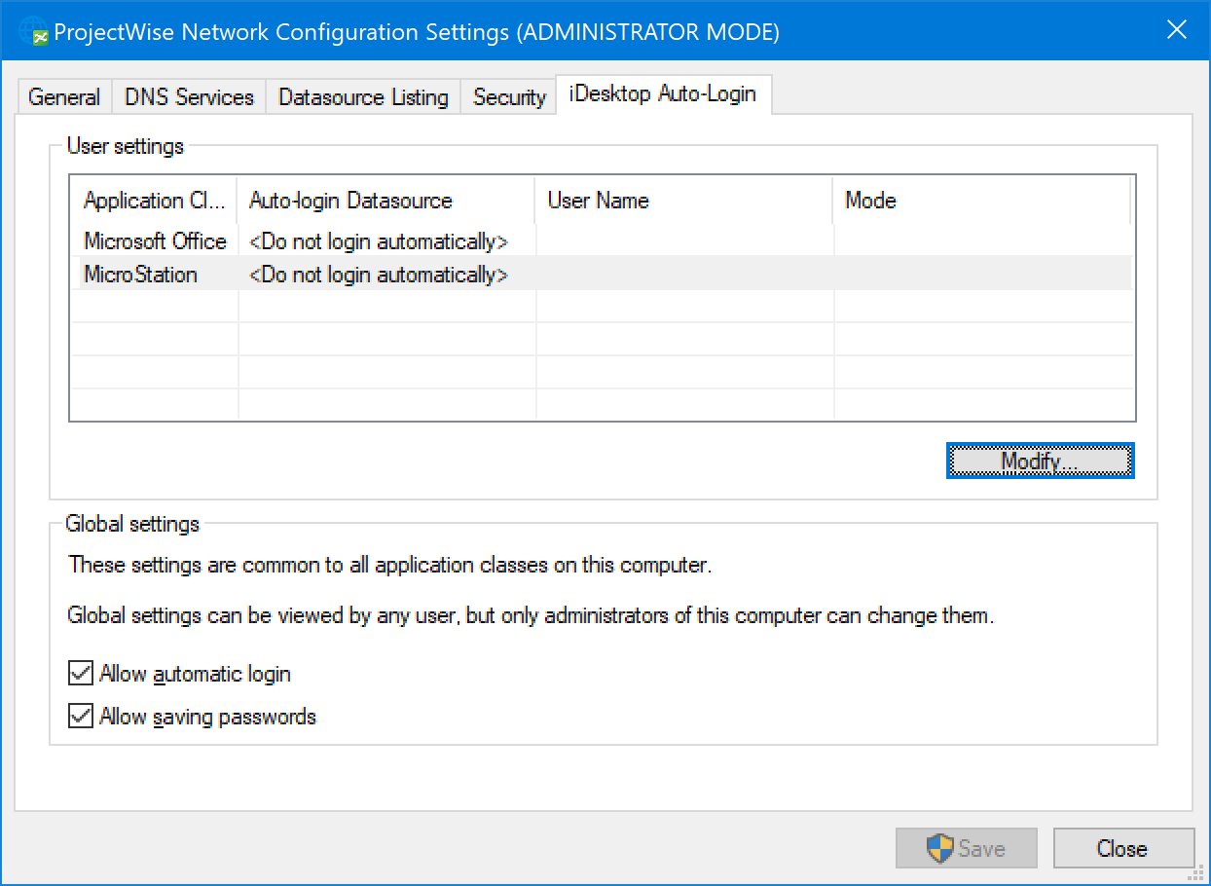
After all settings have been added in the tabs, click Save, then Close.

